Home Assignment: Security automation playbook builder

Introduction:
Build a minimal web app that lets users create and simulate simple security automation playbooks. Each playbook has a name, a trigger, and a list of predefined actions.
The task is expected to take 0.5-1 days.
Outcome: Code exercise as zip or rar with README file to explain how to run it locally.

Core Features
1. User Authentication
- Basic email-based login/registration
- Store users in the database
- Use basic token system to protect routes
2. Playbooks Management
- Each playbook includes:
  - A name
  - A trigger (e.g., Malware Detected, Login Attempt, Phishing Alert)
  - A list of actions (choose from: Isolate Host, Notify Admin, Block IP)
- Users can:
  - Create a new playbook (max 1 trigger + 1–3 actions)
  - View their existing playbooks
  - Delete a playbook (editing is optional)
3. Simulation
- On the dashboard:
  - Select a trigger to simulate an event
  - Show which playbooks match the trigger
  - Display the list of actions that would run
4. Interface
- Minimal React app
- 3 pages:
  - Login/Register
  - Create playbook
  - Simulate Event (with a list of results)

Technical Requirements
Backend
- Node.js / TypeScript
- You can choose database of your choice: Postgres / MongoDB / MySQL etc.
- Use asynchronous methodologies
- REST API endpoints:
  - /auth/register, /auth/login
  - /playbooks (GET, POST, DELETE)
  - /simulateTrigger (POST)
Frontend
- React
- Communication between the client and server should be based on REST or GraphQL calls
- The UI should be easy to work with (although it is not required to spend too much time on CSS)
- Forms for login and creating playbooks
- Display playbooks and simulate triggers

Evaluation Criteria
- Code readability and structure
- Functional REST integration between frontend and backend
- Clean separation of concerns and reusable components
- Error handling
- Tests
- Documentation

Below are examples for the general Idea:
Login /Register Page
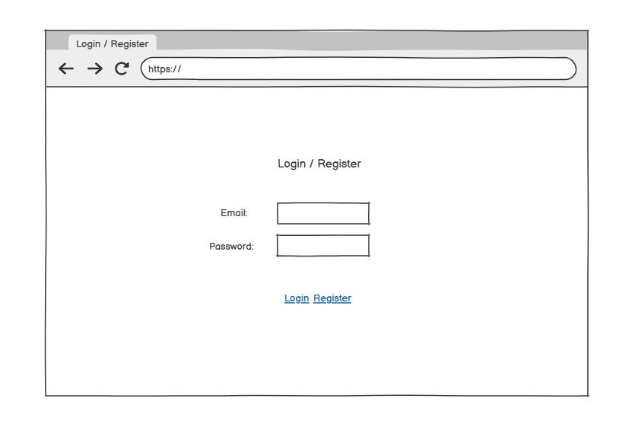

Create Playbook page
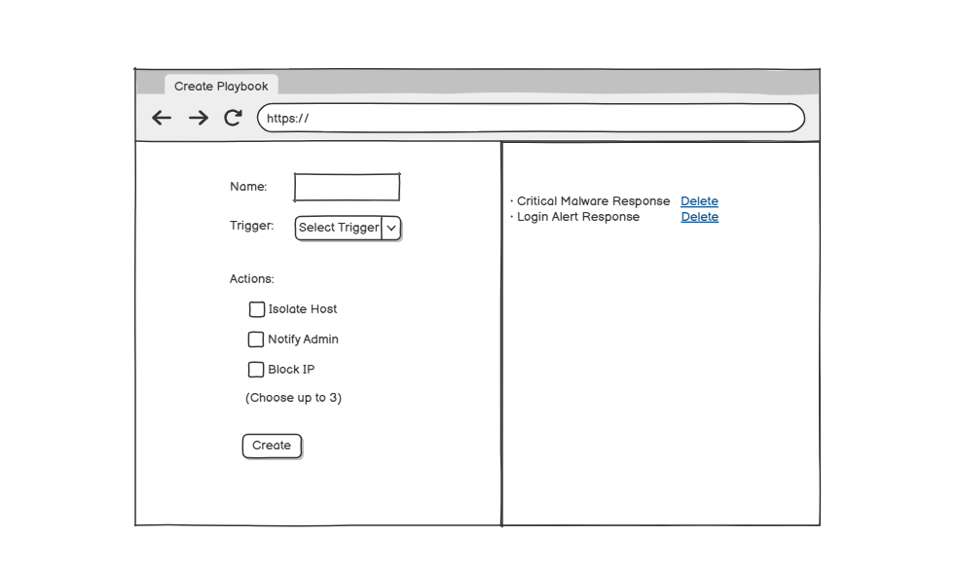Simulate Event page:

